Science (S1 – 3)

Updated curriculum (2017)

Yes! I can fly!

Unit 5: Energy

(Students Version)

Seconded Teacher
Mr. Cheung Chak Man, Andrew

Science Education Section, Curriculum Development Institute, Education Bureau

Science (S1 – 3)

Unit 5: Energy

Topics: Energy conversion and conservation of energy
Estimated lesson time: 80 mins

Yes! I can fly!

【Learning objectives】
After the learning activity, I am able to:
- understand the energy conversion process of a rubber band helicopter;
- recognise that energy is conserved;
- use Sankey diagram to show an energy conversion process; and
- find out the factor affecting the height of a rubber band helicopter reached.

- Activity 1: Making and testing a rubber band helicopter

- Materials

 | Propeller | 1 | rubber bands | 4
 | Craft stick | 1 | hook | 1

- Procedures

Making | 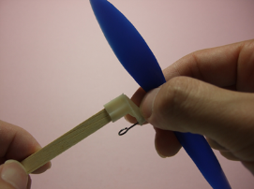 |  | 1. | Insert one end of the craft stick into the plastic mount of the propeller.
 |  |  | 2. | Insert the other end of the craft stick into the hook.
 | 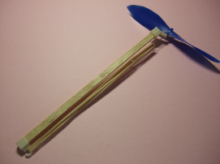 |  | 3. | Attach four rubber bands to the hooks on both ends of the craft stick.
Testing | 5. | Twist the rubber bands 40 times by spinning the propeller (mind the direction).
 | 6. | Release the rubber band helicopter appropriately.  Wear safety goggle

- Result (Circle the correct answer)
The rubber band helicopter takes off / does not take off.
- Reading to learn
Energy cannot be created nor destroyed, but it can be converted from one form to another. We often use various energy converters in our daily lives to convert energy from one form to another that we need. We call it useful energy output. In this energy conversion process, however, there may be some undesired energy output. We call it energy loss.
Figure 1: Car is an energy converter
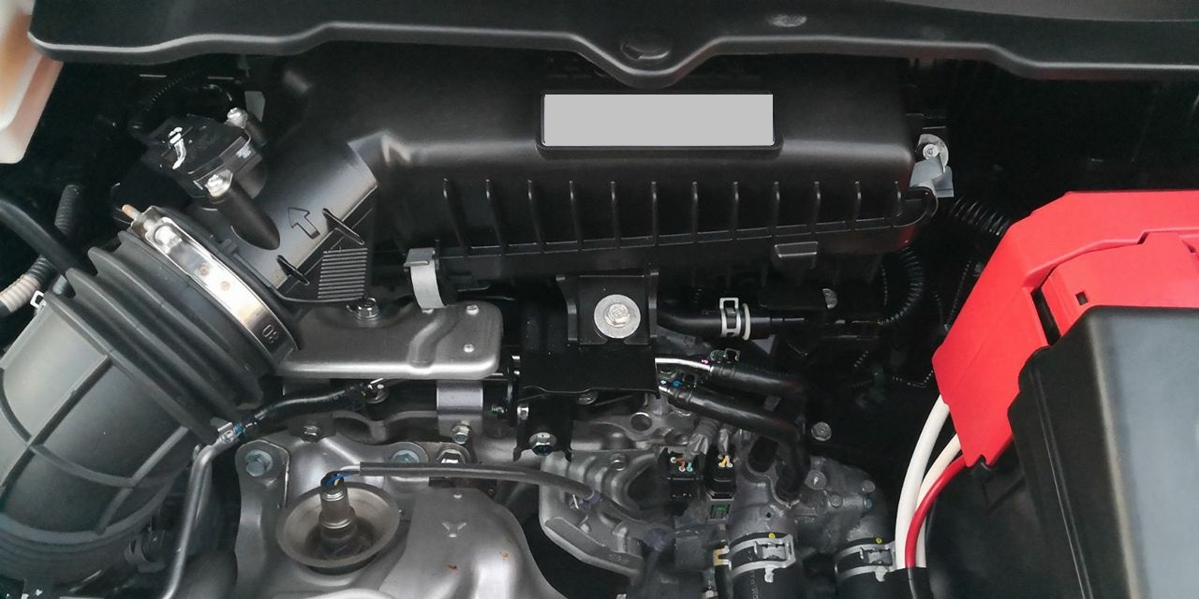
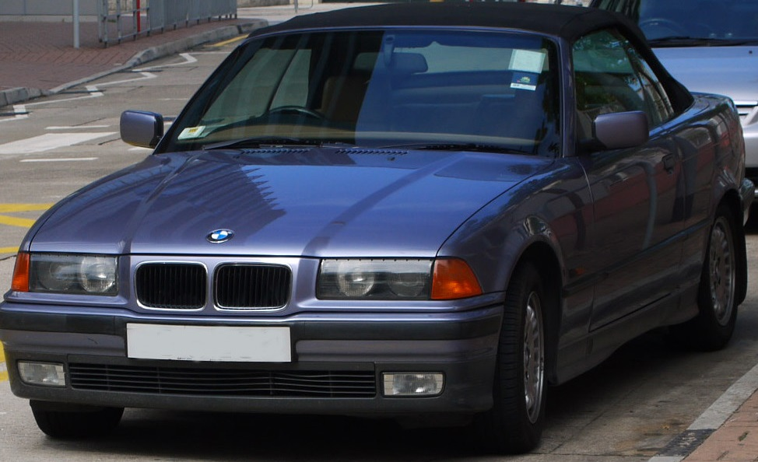

Automotive engine, for example, is used to convert chemical energy stored in the gasoline to kinetic energy of a car. At the same time, heat and sound are released. Therefore in this energy conversion process, kinetic energy is the useful energy output, whereas thermal energy and sound energy are the energy loss.
Figure 2: Automotive engine

Energy is conserved in an energy conversion process: total energy input is equal to the sum of useful energy output and energy loss. In the example above, if the useful energy output (kinetic energy of the car) accounts for 30% of the energy input (chemical energy stored in gasoline), the energy loss (thermal energy and sound energy) would accounts for the remaining 70%.

Sankey diagram shows different forms of energy and their ratios in an energy conversion process. It also shows the concept of energy conservation.
3 units
10 units
As shown in Figure 3, the arrow end at the top left represents the total energy input; its head pointing to the right indicates the useful energy output. The arrow pointing down shows the energy loss.
Energy loss:
heat energy and sound energy
(70%)
Total energy input:
chemical energy stored in the gasoline
(100%)
Useful energy output:
kinetic energy of the car
(30%)

Moreover, the width (not the length) of the arrow is proportion to the amount of energy represented. Because energy is conserved in the energy conversion process, the width of the arrow end is equal to the sum of the width of all sub-arrows.
Figure 3: Sankey diagram of the car
7 units

- Exercise (Fill in the correct form(s) of energy for questions 1 - 4)

- When a gyro is spinning, it has ________________________.

- A basketball is thrown upwards. The higher the position of the basketball, the more ________________________ it stores.

- When a rubber band is stretched, it stores ________________________.

- Electrical energy is converted to light energy and thermal energy by a tungsten light bulb.
- What form(s) of energy is/are the energy input? __________________________
- What form(s) of energy is/are the useful energy output? __________________________
- What form(s) of energy is/are the energy loss? __________________________
- (Cont’d) If the useful energy output accounts for 10% of the total energy input of a tungsten light bulb, which of the following Sankey diagrams shows its energy conversion process?
(Fill in the correct answer in the box)

Useful energy output
A. | Total energy input  Energy loss | B. | Useful energy output  Total energy input  Energy loss
C. | Energy loss  Useful energy output  Total energy input | D. | Energy loss  Useful energy output  Total energy input

- Consider the testing result of rubber band helicopter in activity 1.

- Which of the following Sankey diagrams best shows its energy conversion process?
(Put a tick “√” in the appropriate box)

Useful energy output

Useful energy output
Total energy input
Total energy input

Energy loss
Energy loss

(Fill in the correct form(s) of energy for questions b and c)
- What form(s) of energy is/are the energy input? _______________________________
- What form(s) of energy is/are the useful energy output? _______________________________

- Activity 2: Modifying the rubber band helicopter

- Procedures
Modifying
Figure 4: Modified rubber ban helicopter |  | 1. |  | Fix the airfoil on the craft stick using double-side tape.  Wear safety goggle
Testing
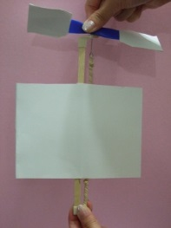  Figure 5  Release first | 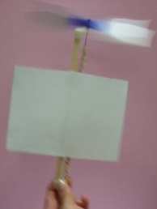  Figure 6  Release later |  | 2. |  | Twist the rubber bands 40 times (mind the direction).
 |  |  | 3. |  | Release the rubber band helicopter appropriately. Under safe conditions, release the propellers first (Figure 5) and then the lower part of the rubber band helicopter (Figure 6).
 |  |  | 5. |  | Observe the height of flight of the rubber band helicopter.

- Result (Circle the correct answer)
The rubber band helicopter takes off / does not take off.

Figure 7
- Discussion (Put a tick “√” in the appropriate box)
Useful energy output
With reference to the Sankey diagram for the original rubber band helicopter in Figure 7, which of the following best shows the energy conversion process after modification?
Total energy input

Energy loss

Useful energy output
Useful energy output
Useful energy output

Total energy input
Total energy input
Total energy input

Energy loss
Energy loss
Energy loss

- Scientific investigation

- Aim: Find the relation between “the times of rubber bands twisted” and “the height of the
rubber band helicopter reached”

- Material: The modified rubber band helicopter

- Procedures
Wear safety goggle
PartⅠ | - Twist the rubber bands 40 times (mind the direction).
 | - Release the rubber band helicopter appropriately.
 | - Observe the height of the rubber band helicopter reached.
Part П | - Twist the rubber bands 60 times (mind the direction).
 | - Repeat Steps 3 and 4.
Part Ш | - Twist the rubber bands 80 times (mind the direction).
 | - Repeat Steps 3 and 4.
 | - Complete the table below.

- Results (Fill in or circle the correct answers)

Variable | PartⅠ | Part П | Part Ш | Change in variable?
- Times of rubber bands twisted | 40 times | 60 times | 80 times | Yes / No
- Length of propeller |  |  |  | Yes / No
- Number of rubber bands |  |  |  | Yes / No
- Length and width of airfoil | length：  width： | length：  width： | length：  width： | Yes / No
- Height of the rubber band helicopter reached | low / medium / high | low / medium / high | low / medium / high

- Conclusion (Circle the correct answer)

When the times of rubber bands twisted are increased, the height of the rubber band helicopter reached is increased / is decreased / is unchanged.

- Discussion (Fill in the correct answer in the box)

Useful energy output

Total energy input

Energy loss
Figure 8

With reference to the Sankey diagram for Part Ⅰ (rubber band twisted 40 times) of the scientific investigation in Figure 8, which of the following best shows the energy conversion process in Part Ш (rubber band twisted 80 times)?

A. | B.
Useful energy output

Useful energy output
Total energy input
Total energy input

Energy loss
Energy loss

C. | D.  Useful energy output
Useful energy output
Total energy input
Total energy input

＝

Energy loss
Energy loss

- Summary

Use the following vocabularies to write what you have learnt in this activity.

Related vocabularies: | Energy, energy conversion, form of energy, energy converter, energy input,  effective energy output, energy loss, rubber band helicopter, airfoil, Sankey diagram.

In this activity, I have learnt:

- Self-evaluation

Items |  | Evaluation  (Put a tick “√” in the appropriate box)
 |  | Highly satisfactory | Satisfactory | Unsatisfactory | Highly unsatisfactory
1. | I understand the energy conversion process of a rubber band helicopter.
2. | I recognise that energy is conserved.
3. | I can use Sankey diagram to show an energy conversion process.
4. | I can find out the factor affecting the height of a rubber band helicopter reached.

End

